Name: Klasse:
Zeichen der Taufe

Während einer Tauffeier spielen vier Zeichen eine besondere Rolle.
Erkläre, welche Bedeutung sie haben.

_________________________________________________________________________________
_______________________________________________________________________________________________________________________________________
___________________________________________________

_________________________________________________________________________________
_______________________________________________________________________________________________________________________________________
___________________________________________________

Wasser
Chrisam
(kostbares Öl)

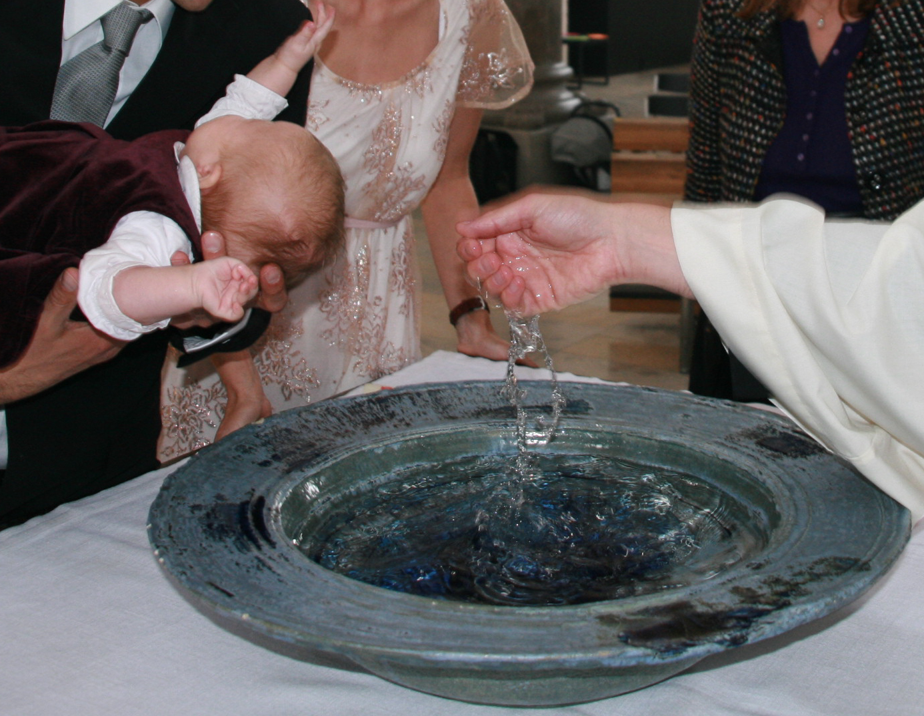
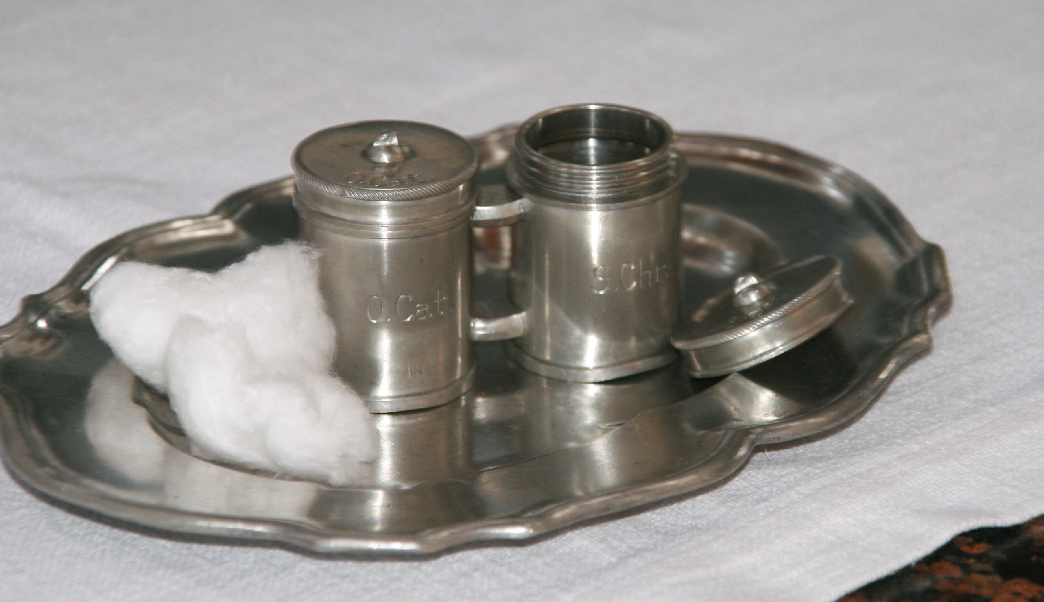

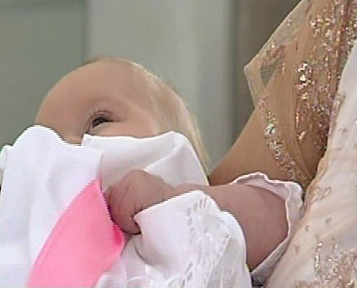
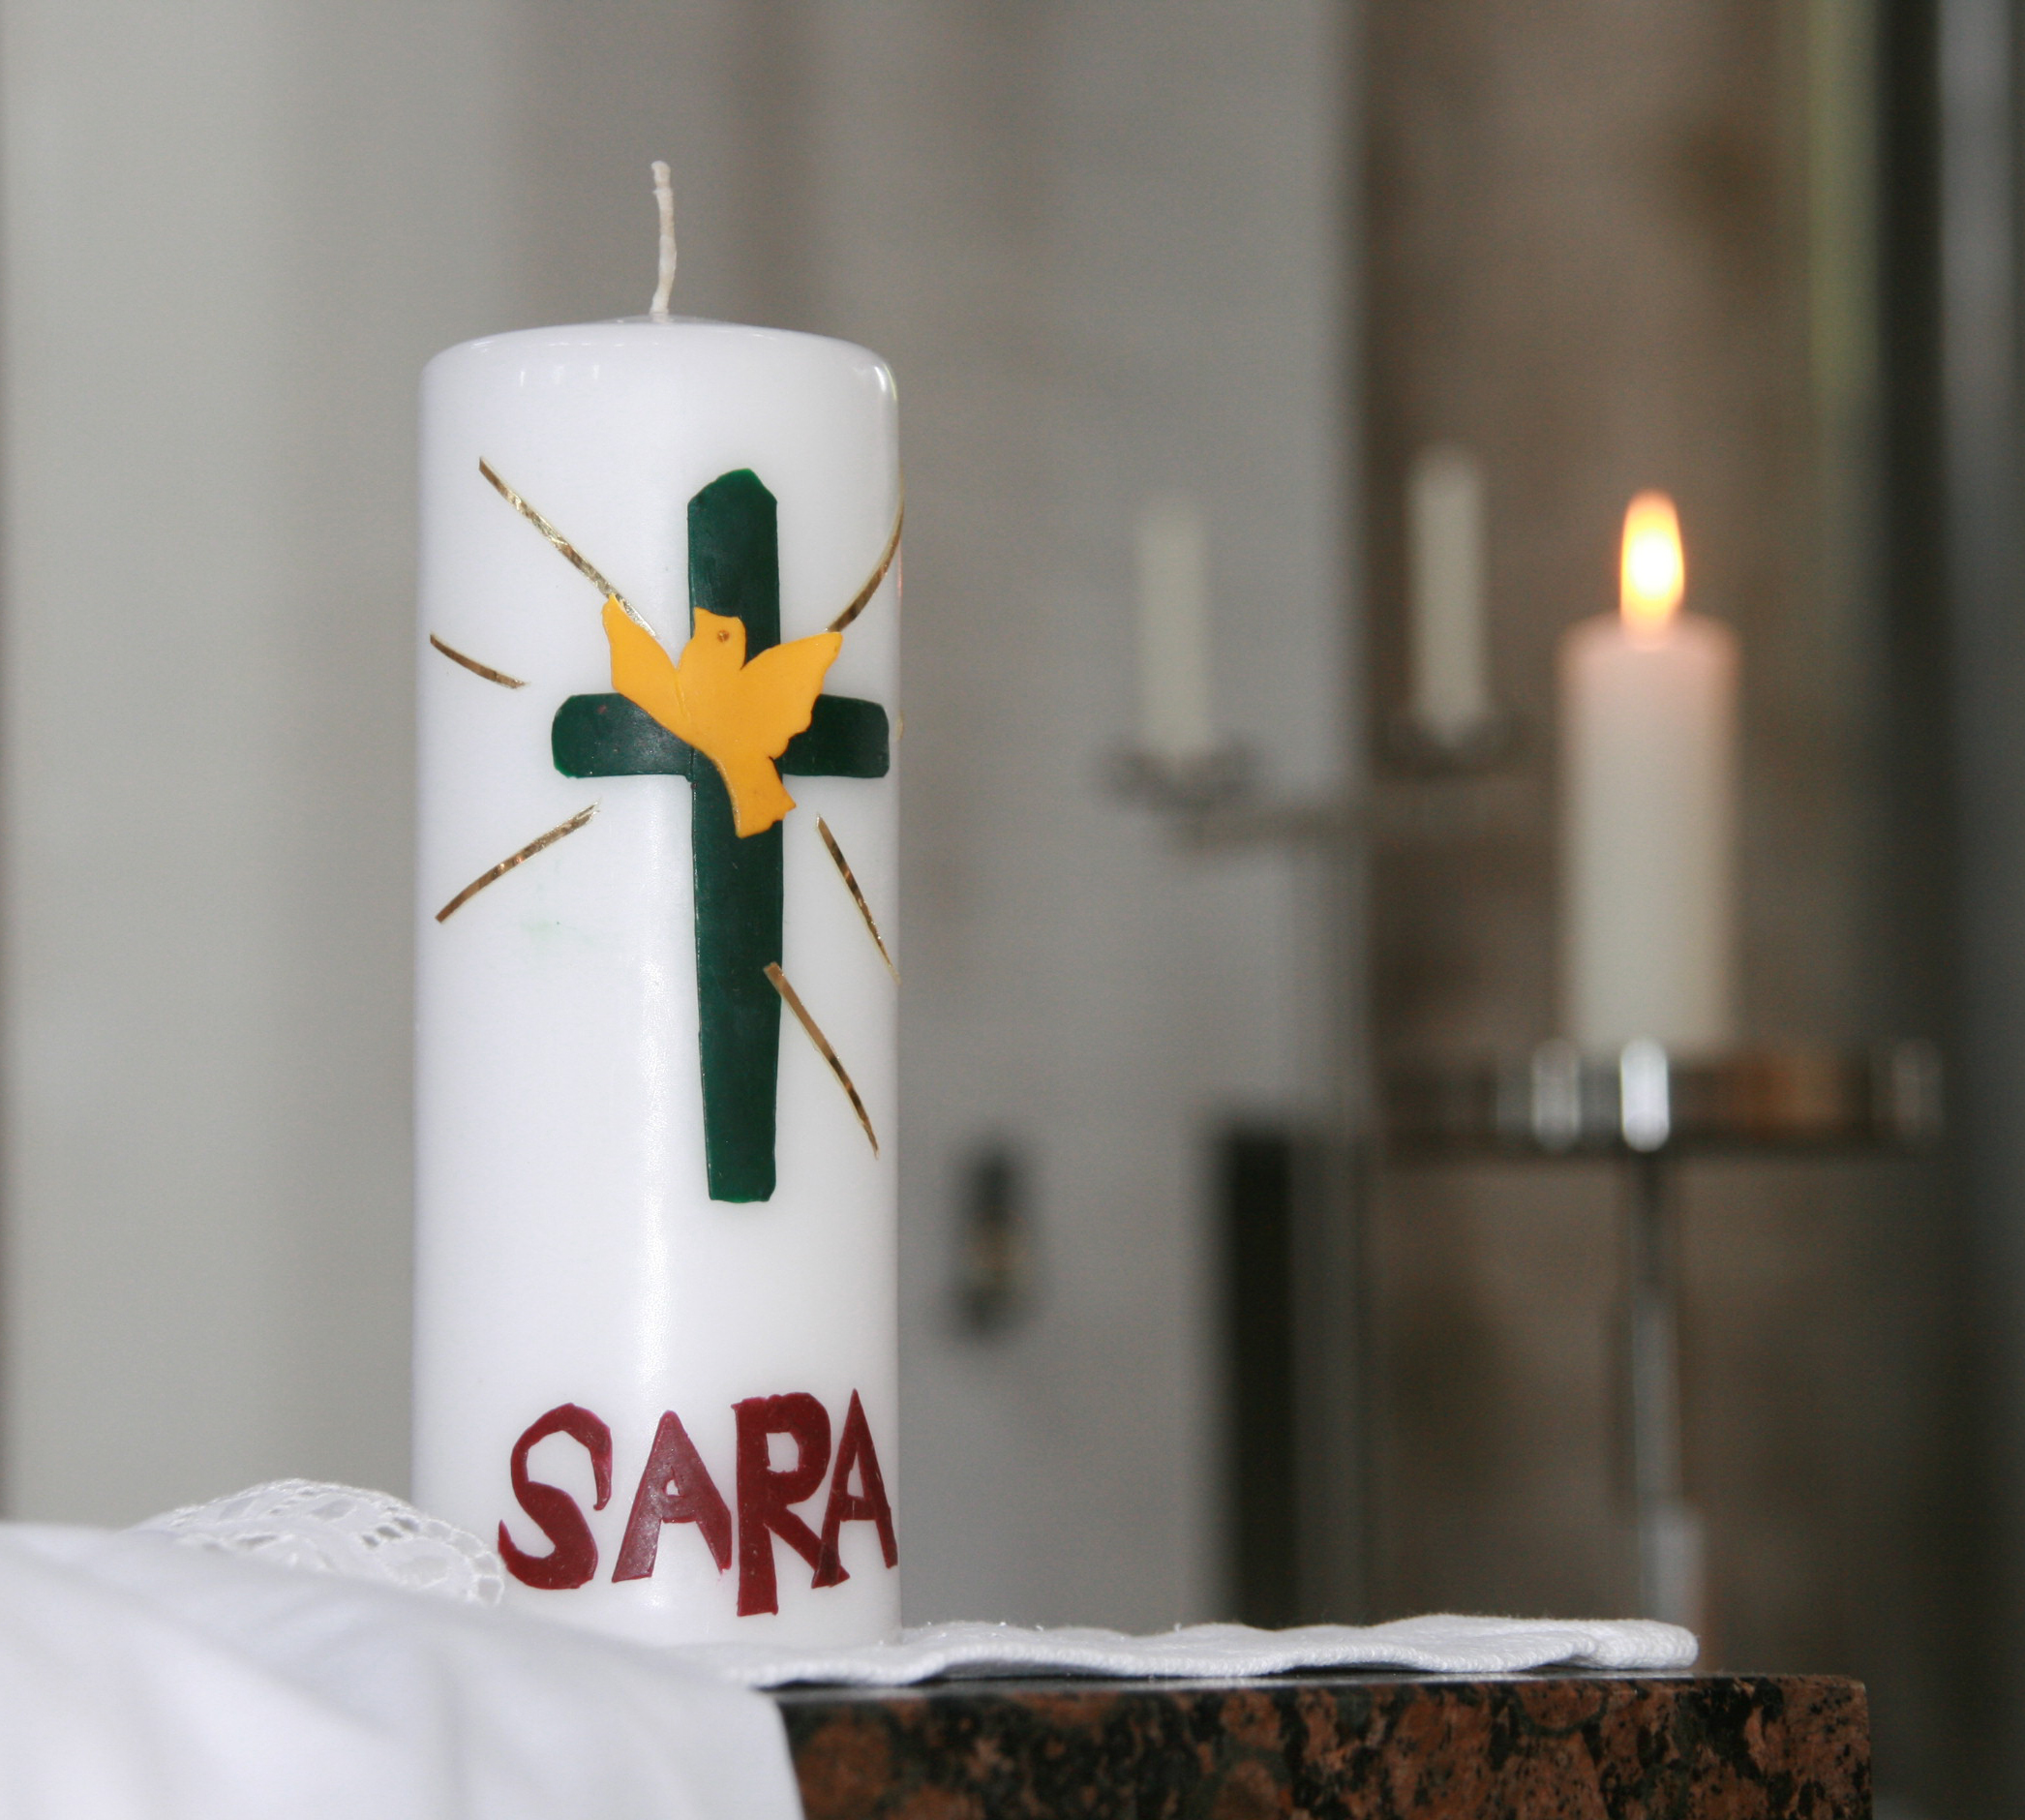

_________________________________________________________________________________
__________________________________________________________________________________________________________________________________________________________________________________________

________________________________________________________________________________
____________________________________________________________________________________________________________
___________________________________________________

Taufkerze

Weißes Taufkleid

